STAT 440 : BUSINESS STATISTICS
International Labor
Introduction to Data
The International Labor data includes records of labor values for seven nations -- USA, Canada, Australia, Japan, France, Germany and Italy -- over 40 separate times.
Summary Statistics
Upon reviewing the summary statistics, it was apparent that the average labor values across all categories for Japan were the lowest, with an average of 2.12 and a maximum of 4.10. In addition, Canada had the highest median labor values and France had the largest variance as indicated by their inter-quartile ranges. Furthermore, there was a single outlier in the dataset which was the United States, indicating that there may have been at least one unusually high measurement made in at least one time period.
Statistical Summary of International Labor Data by Country
 | U.S. | Canada | Australia | Japan | France | Germany | Italy
Min | 3.50 | 3.40 | 1.30 | 1.10 | 1.20 | 0.30 | 2.40
Q1/25% | 5.27 | 5.57 | 2.25 | 1.37 | 2.45 | 0.70 | 3.50
Median | 5.65 | 7.50 | 5.95 | 2.10 | 5.75 | 3.40 | 4.40
Mean | 6.04 | 7.56 | 5.46 | 2.09 | 6.32 | 3.57 | 5.73
Q3/75% | 7.03 | 9.53 | 8.15 | 2.52 | 10.33 | 6.30 | 7.35
Max | 9.70 | 11.90 | 10.90 | 4.10 | 12.50 | 7.80 | 12.30
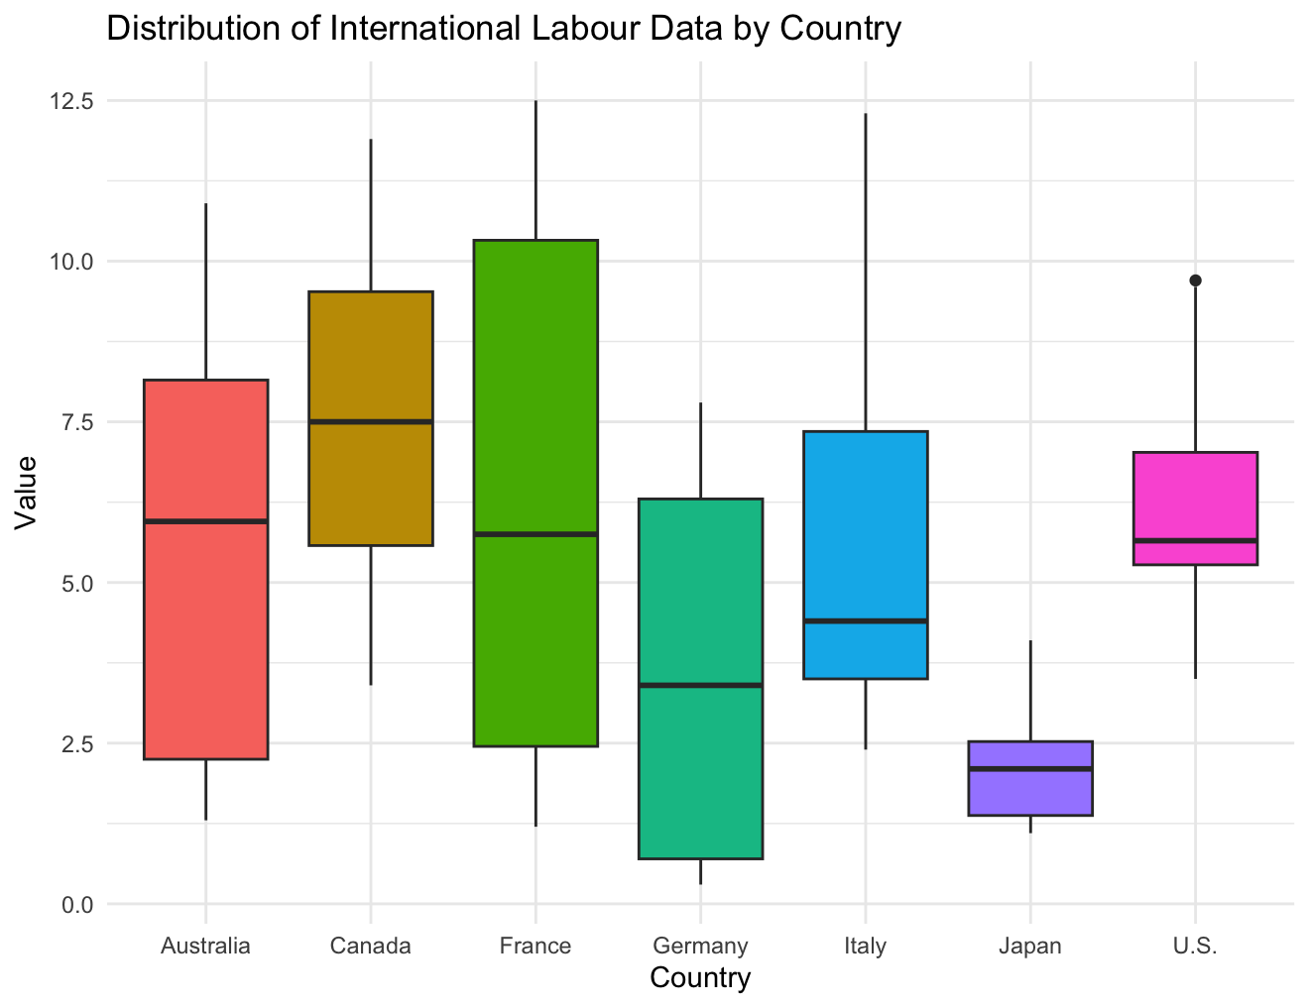
Time Trends
Reviewing the line graphs generated from the data revealed some interesting trends in the various countries. France, Italy and Germany demonstrated steady upward trends in their measurements over the 40 time periods analyzed. On the other hand, both Canada and Australia experienced sharp increases prior to displaying fluctuations. The United States' trend line was the most variable and therefore exhibited the least consistency among all seven countries. Lastly, Japan's trend line demonstrated remarkable stability with the least variability observed among all seven countries.
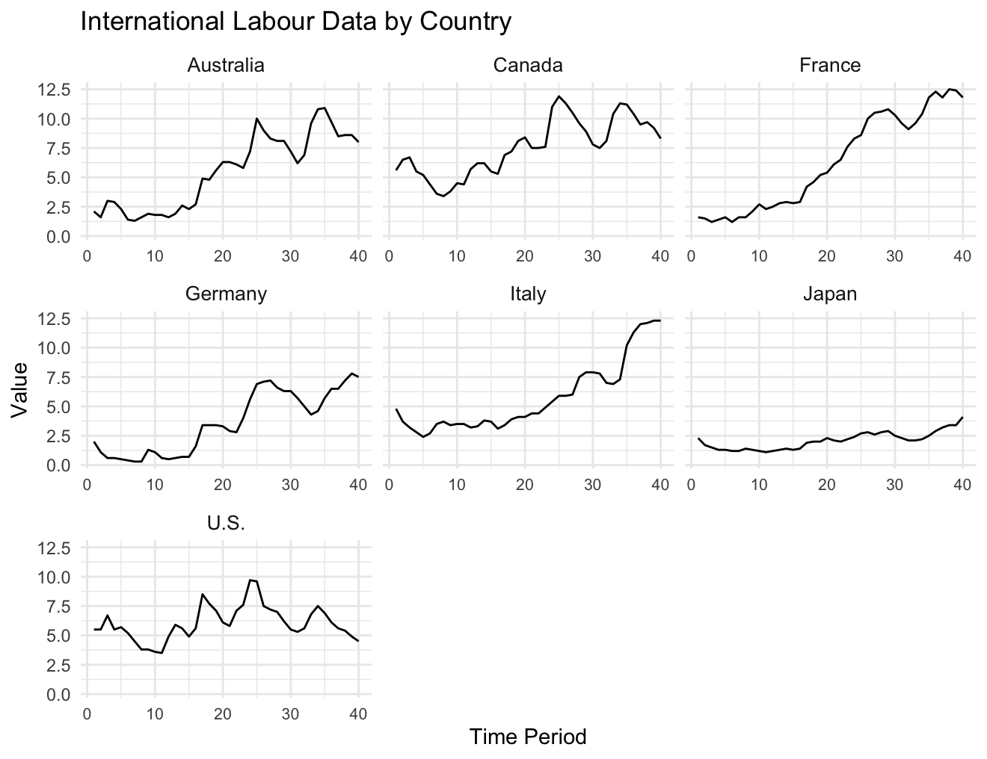
Correlation Analysis
Based upon the correlation analysis completed on the data, it appears that France and Germany exhibit the greatest positive relationship as evidenced by a correlation coefficient of 0.96. As such, they appear to be moving in near-perfect synchrony. Similarly, Australia, France and Germany tend to display strong positive correlations with one another. Conversely, based on the weak correlation coefficients between the United States and the remaining six countries (particularly Italy), it appears that the United States has established the fewest connections of any of the seven countries. Specifically, the correlation coefficient between Italy and the U.S.A. was found to be only 0.03; thus, Italy and the U.S.A. can be considered to be nearly independent of each other.
Correlation Table of International Labor Data Across Selected Countries
 | U.S.A. | Canada | Australia | Japan | France | Germany | Italy
U.S.A. | 1.00 | 0.69 | 0.54 | 0.30 | 0.34 | 0.42 | 0.03
Canada | 0.69 | 1.00 | 0.94 | 0.76 | 0.85 | 0.85 | 0.65
Australia | 0.54 | 0.94 | 1.00 | 0.82 | 0.94 | 0.91 | 0.77
Japan | 0.30 | 0.76 | 0.82 | 1.00 | 0.89 | 0.93 | 0.88
France | 0.34 | 0.85 | 0.94 | 0.89 | 1.00 | 0.96 | 0.89
Germany | 0.42 | 0.85 | 0.91 | 0.93 | 0.96 | 1.00 | 0.84
Italy | 0.03 | 0.65 | 0.77 | 0.88 | 0.89 | 0.84 | 1.00

